Create EC2 with MSSQL and connect with SSMS and take backup

Step 1: Create EC2 Instance with SQL Server
- Go to the AWS Management Console.
- Navigate to EC2 > Launch Instance.
- Name your instance: e.g., SQLServer-EC2.
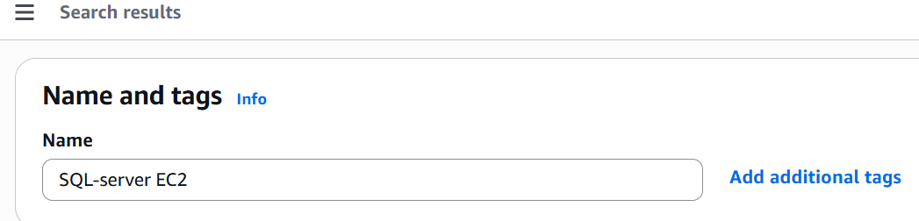
- Under Application and OS Images (Amazon Machine Image):
  - Choose Microsoft Windows Server with SQL Server (e.g., Microsoft Windows Server 2022 with SQL Server 2019 Standard).
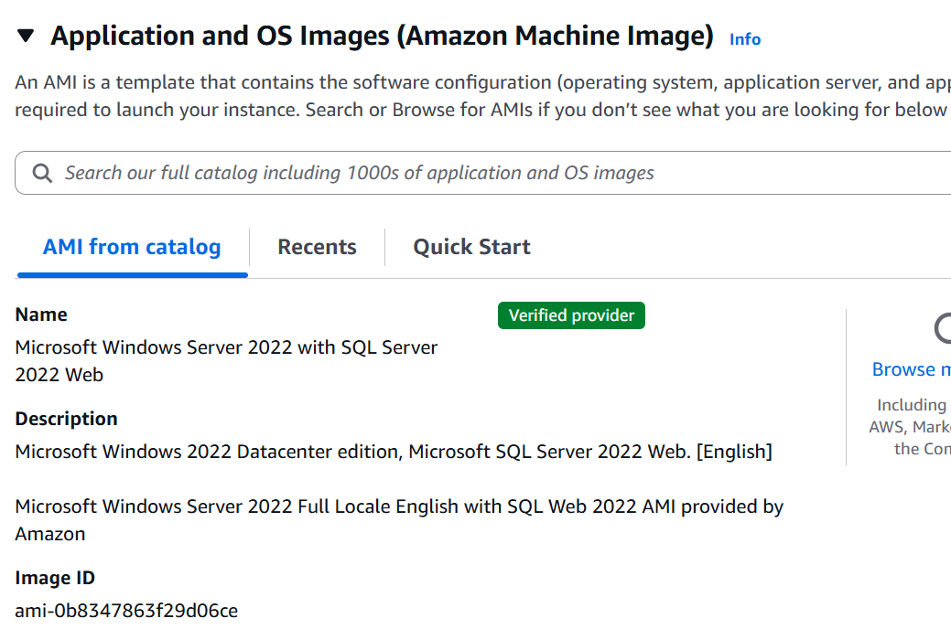
- Choose an instance type (e.g., t3.medium or larger for SQL workloads).
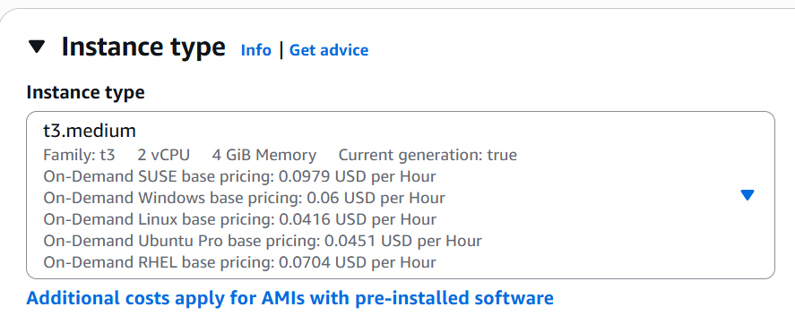
- Key pair: Choose an existing one or create a new key pair (for RDP access).
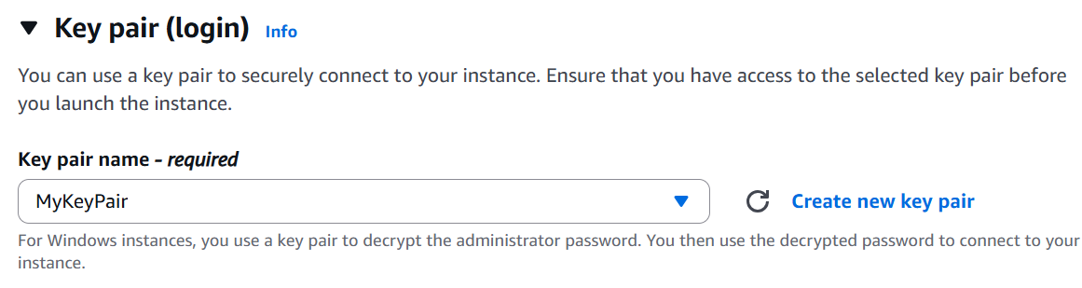
- Network settings:
  - Place it in a VPC and public subnet.
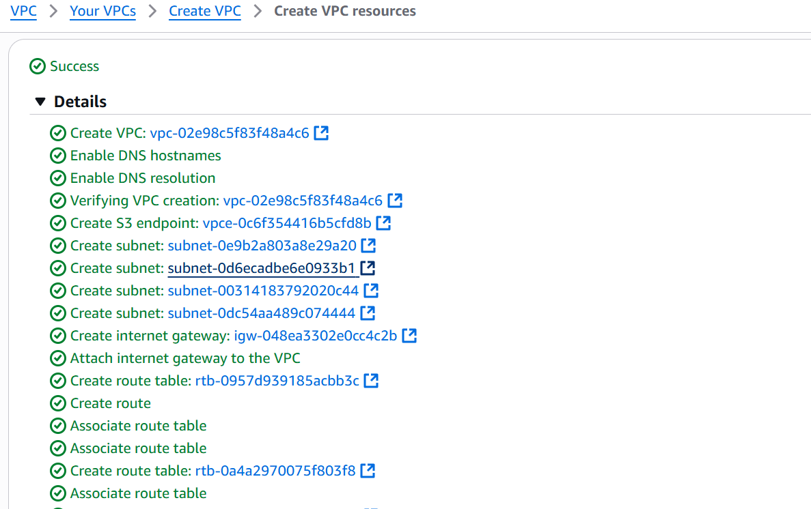
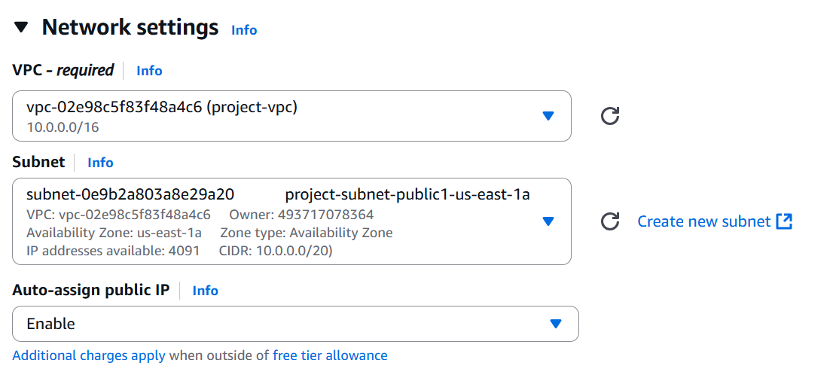
  - Enable Auto-assign public IP.
  - Security group: Add RDP (port 3389) and MSSQL (port 1433) inbound rules.
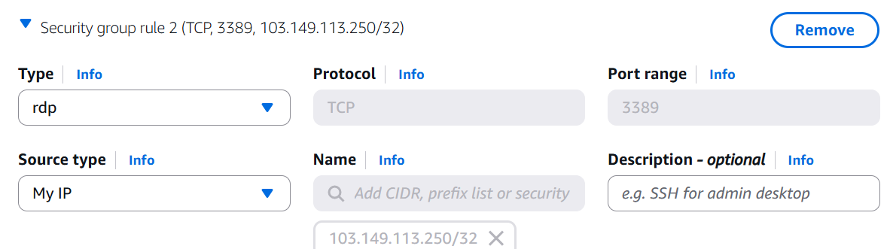

✅ Step 2: Connect to EC2 via Remote Desktop
- Once launched, go to Instances > Connect > RDP client.
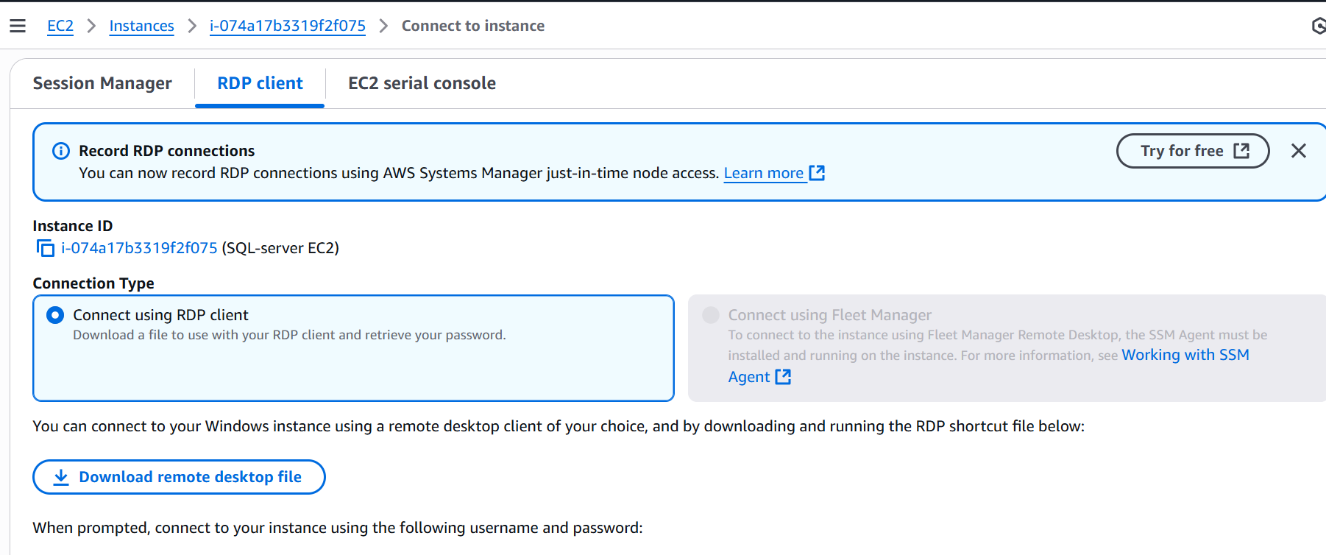
- Download the Remote Desktop File.
- Click Get Password, upload your key pair .pem file, and decrypt.
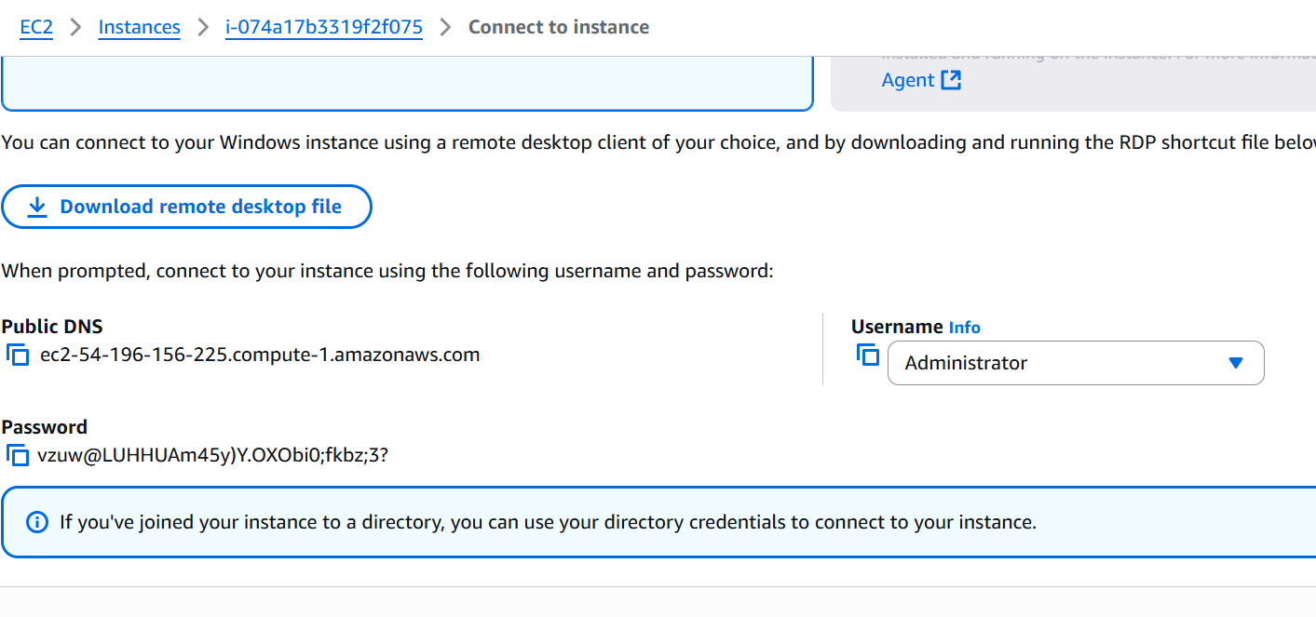
- Open the RDP file and log in using the username (usually Administrator) and the decrypted password.

✅ Step 3: Check SQL Server is Running
- On the EC2 instance:
  - Open SQL Server Management Studio (SSMS) (already installed on the image).
  - Connect to: localhost or .\SQLEXPRESS depending on the version.
  - Use Windows Authentication.

✅ Step 4: Allow Remote Connections to SQL Server
- Open SQL Server Configuration Manager.
- Enable TCP/IP under SQL Server Network Configuration.
- Restart the SQL Server service.
- Open Windows Defender Firewall:
  - Add Inbound Rule for TCP port 1433.
PART 5: Create Database and Table (Add Data)
- Create a New Database
Create database college;
- Create Table and Insert Data
PART 6: Take Database Backup
1. Backup Using SSMS GUI
- Right-click the database MySampleDB > Tasks > Back Up.
- Set:
  - Backup type: Full
  - Destination: e.g., C:\Backups\MySampleDB.bak
- Click OK to start the backup.

2: Add a Backup Step
- Go to Steps ➝ New
- Name: FullBackup
- Type: Transact-SQL script (T-SQL)
- Database: your target DB

